PROFILE
Department | Computer Sci & Engineering |  | 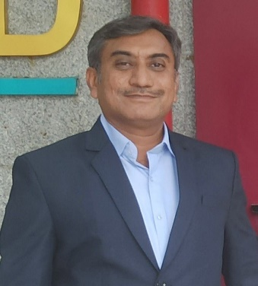
Title (Mr. / Mrs. / Miss / Dr. / Prof.) | Dr.
First name | Avinash
Middle name | Shivappa
Surname | Kapse
Designation | Professor & Head of Department, Dean R&D
UG degree | B.E.(CSE)
UG University | S.G.B.A.U. Amravati
UG Division | First
PG Degree | M.E (CSE)
PG University | (Government College of Engineering )D.B.A.M.U.Aurangabad
PG Division | First Division with Distinction
PhD (Yes / No / Pursuing) | Yes
Highest Degree (Post Graduate /  Graduate) | Ph. D. ( Computer Science & Engineering)
Other Qualifications
Email | avinash.kapse@aecc.ac.in
Experience (Teaching) | 21.5 Yrs (UGC Approved)
Experience (Industry) | 10 months
Publications | 82
Papers Presented in conference | 14
Books Published | 05
STTP/ FDP Attended | 16
Number of PhD, M.Phil, M.Tech Guided | Ph. D- 04 Awarded , 01 Pursuing, M.E -17 Awarded, 15 Pursuing

Dr. Avinash Shivappa Kapse
Professor & Head of Department, Dean R&D

