PROFILE
Department | Electronics & Telecommunication |  | 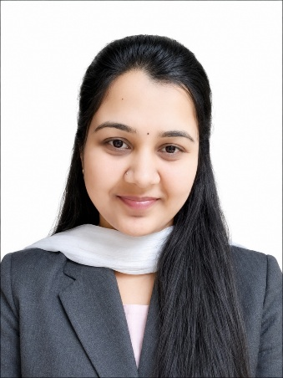
Title (Mr. / Mrs. / Miss / Dr. / Prof.) | Miss.
First name | Divya
Middle name | Rahul
Surname | Bhatkar
Designation | Assistant Professor
UG degree | B.E. Electronics & Telecommunication Engineering
UG University | Sant Gadge Baba Amravati University, Amravati.
UG Division | First
PG Degree | M. E (Digital Electronics)
PG University | Sant Gadge Baba Amravati University, Amravati.
PG Division | First
PhD (Yes / No / Pursuing) | --
Highest Degree (Post Graduate / Graduate) | Post Graduate
Other Qualifications | -
Email | missdivyarahul@gmail.com
Experience (Teaching) | 07 Year
Experience (Industry) | --
Publications | --
Papers Presented in conference | National Journal: | 02
Papers Presented in conference | International Journal: | 00
Books Published | --
STTP/ FDP Attended | 06
Number of PhD, M.Phil, M.Tech Guided | --

Miss. Divya Rahul Bhatkar
Assistant Professor

