PROFILE
Department | Electronics & Telecommunication Engg |  | 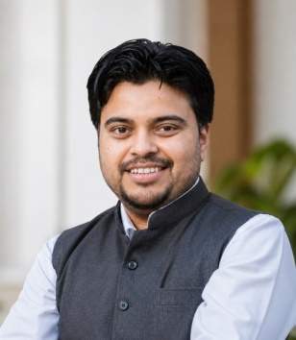
Title (Mr. / Mrs. / Miss / Dr. / Prof.) | Mr
First name | Swapnil
Middle name | Haribhau
Surname | Kudke
Designation | Assistant Professor
UG degree | B.E. Electronics & Telecommunication Engineering
UG University | Sant Gadge Baba Amravati University, Amravati.
UG Division | First
PG Degree | M. E. Digital Electronics
PG University | Sant Gadge Baba Amravati University, Amravati.
PG Division | First
PhD (Yes / No / Pursuing) | -
Highest Degree (Post Graduate / Graduate) | Post Graduate
Other Qualifications | Diploma in Electronics
Email | swapnil.kudke@aecc.ac.in
Experience (Teaching) | 14 Year
Experience (Industry) | --
Publications | Paper published International Journal: 07  Patent Published : 01
Papers Presented in conference | National Journal: | 1
Papers Presented in conference | International Journal: | 1
Books Published | 3 Books Published
STTP/ FDP Attended | 17
Number of PhD, M.Phil, M.Tech Guided | --

Mr. Swapnil H. Kudke
Assistant Professor

