PROFILE
Department | Computer Science & Engineering |  | 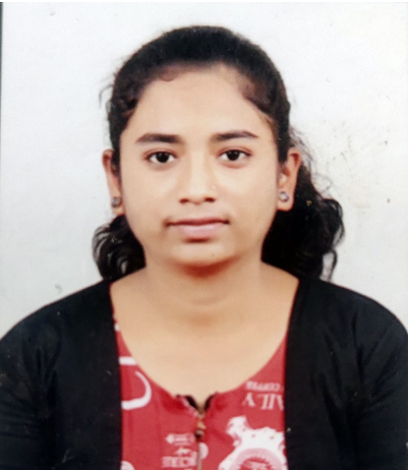
Title (Mr. / Mrs. / Miss / Dr. / Prof.) | Miss
First name | Trupti
Middle name | Sanjay
Surname | Pawar
Designation | Assistant Professor
UG degree | Bachelor of Engineering (CSE)
UG University | Sant Gadge Baba Amravati University
UG Division | First Division
PG Degree | ---
PG University | --
PG Division | ---
PhD (Yes / No / Pursuing) | No
Highest Degree (Post Graduate /  Graduate) | -----
Other Qualifications | NA
Email | Trupti.pawar@aecc.ac.in
Experience (Teaching) | ------
Experience (Industry) | ----
Publications | NA
Papers Presented in conference | National: NA
Papers Presented in conference | International: NA
Books Published | NA
STTP/ FDP Attended | NA
Number of PhD, M.Phil, M.Tech Guided | NA

Full Name
Assistant Professor (CSE)

